

**Notre Dame University Bangladesh**

Department of Computer Science and Engineering

 CSE 1201: Structured Programming Language, Fall 2022

**Submitted By Submitted To**

**Shazidul Alam A. H. M. Saiful Islam**

**Batch: CSE- 19 Associate Professor, Chairman, CSE**

**Id: 0692220005101009 NDUB**

**Subject: ENG 1207**

**Exercise I**

1. a. Write the following numbers in normal decimal notation:

Ans:

103e-4 = 0.0103

1.2345e+6 = 1234500

123.45e+3 = 123450

b. Write the following numbers in C scientific notation:

Ans:

1300 = 1.3e+3

123.45 = 1.2345e-2

0.00426 = 4.26e-5

2. Indicate which of the following are valid type int, double, or char constants in C and which are not. Identify the data type of each valid constant.

Ans:

'PQR' = char

15E-2 35 = int

'h' = char

-37.491 = double

.912 = double

4,719 = int

'true' = char

"T" = char

4.5e3 = int

'$' = no constant

3. What would be the best variable type for the area of a circle in square inches?

Ans: double

Which type for the number of cars passing through an intersection in an hour?

Ans: int

The first letter of your last name?

Ans: char

4. Show the output displayed by the following program lines when the data entered are 5 and 7:

Ans:

#include<stdio.h>

int main()

{

int Integers;

int number1,number2;

int task1,task2;

printf("Enter two integers\n");

scanf("%d",&Integers);

number1=Integers%10;

number2=Integers/10;

task1=number2+5;

task2=3*number1;

printf("m=%d\nn=%d",task1,task2);

return 0; }

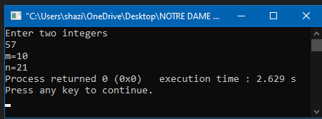

5. Show the output displayed by the following lines if the value of exp is 11:

Ans:

#include<stdio.h>

int main()

{

int exp;

printf("Your exp is\n");

scanf("%d",&exp);

if (exp=11);

{

printf("My name is\n");

printf("Abrar Hossain");

printf("\n");

printf("I live in ");

printf("Dhaka,BD\n");

printf("and I have %d years",exp);

printf(" of programming language\n");

return 0;

} }

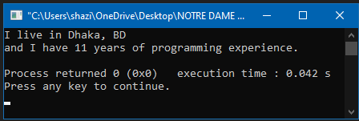

6. How could you modify the code in Exercise 5 so that “My name is Abrar Hossain.” and “I live in Dhaka, BD” would appear on the same line without running together (i.e., with a space between the period and the “I”)?

Ans:

#include<stdio.h>

int main()

{

int exp;

printf("Your exp is\n");

scanf("%d",&exp);

if (exp=11);

{

printf("My name is Abrar Hossain\t and I live in Dhaka,BD.\n");

printf("I have %d years",exp);

printf(" of programming language\n");

return 0;

}

}

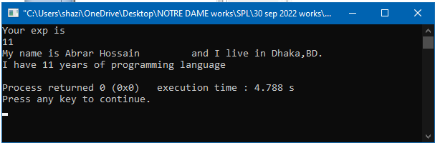

7. Write a C program that asks the user to enter the radius of a circle and then computes and displays the circle’s area. Use the formula

*Area* = *PI* x *Radius* x *Radius*

where *PI* is the constant macro 3.14159.

Ans:

#include<stdio.h>

main()

{

float radius;

float ar_of_cr;

printf("Enter the radius\n");

scanf("%f",&radius);

ar_of_cr=3.14159*radius*radius;

printf("The area of the circle is %f",ar_of_cr);

return 0;

}

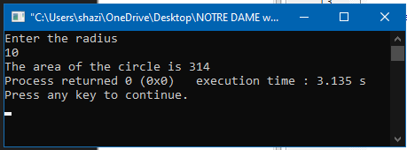

8. What will be the output? printf("%d\t",sizeof(6.5)); printf("%d\t",sizeof(90000)); printf("%d",sizeof('A'));

Ans:

#include<stdio.h>

main()

{

printf("%d\t",sizeof(6.5));

printf("%d\t",sizeof(90000));

printf("%d",sizeof('A'));

return 0;

}

